Final Year Project

**Project Title:**

Global Aid Tracker

**Group Members:**

Areeba Junaid - B19103012

Syeda Fatima Zahid - B19103063

Kainat Zulfiqar -

**Project Supervisor:**

Dr. Muhammad Saeed

General:

BSSE- Morning

**Introduction:**

Global Aid Tracker is a blockchain based app where you can find out how many donations we have at a time as well as can request for those donations in the meantime you can also track your donations record and much more. Platform that seamlessly connects donors and donee worldwide, providing complete transparency, security, and trust in every donation.

This innovative app empowers donors to make a real impact, ensuring their contributions reach the intended beneficiaries while eradicating concerns about mismanagement or fraud.

**Scope:**

Donor can provide a list of assets they can donate and donee can see available donations and can request for the donation, donor can manage and respond to requests and provide donations if possible. Blockchain immutable ledger in the app ensures that all donations and transactions are recorded transparently. Donors can track their contributions in real-time.

**Purpose:**

Organizations provide aid/donations to relieve suffering caused by natural or man-made disasters such as famine, disease and war or to fulfill needs of needy people. Global aid tracker aims to improve access of donations to the donee/needy people.It also helps donors to provide a list of assets they are willing to provide as well as the requests they have received from donees. By aggregating global donation data, the app can highlight trends and areas of needs, potentially targeting more effective philanthropic efforts.

**System Features:**

1- Keep record of donor and donee.

2- User friendly.

3- Secure.

4- Keep track of accepted completion and request of donations.

5- Send a donation.

6- Donation tracking.

7- Multi-Language support.

8- Donor engagement.

**Functional Requirements:**

1- An app must allow users to register as a donor or donee.

2- An app must maintain a history record of all the donations.

3- Donors can view the list of donations donee want.

4- Donee can view a list of donation offers by the donor and can apply for it.

5- An accepted donation should be seen in the history page.

6- Allow users to rate and review donations to provide feedback and inform others.

7- Provide a mechanism for users to manually add offline donations to their profiles.

**Non Functional Requirements:**

1- Should be scalable.

2- Failure transparency.

3- Ease of use.

4- Performance(must be able to handle the required number of users without any degradation in performance).

5- Ensure that the app responds to user interactions quickly, with minimal delay.

6- Implement secure authentication methods to protect user accounts.

7- Provide support for multiple currencies, languages and regional preferences.

8- Ensure seamless integrations with payment gateways, social media platforms and other third-party services.

**External Interface Requirements:**

1- User friendly interface.

2- Analytics and monitoring tools.

3- Accessibility tools: Ensure compatibility with screen readers and assistive technologies for users with disabilities.

4- CMS Integration: If applicable integrate with a CMS to manage and update content on the app, such as news articles and success stories.

**Technologies Used:**

Blockchain Ethereum, Ether.js, CSS Tailwind, React, Hardhat.

**Activity Diagram:**

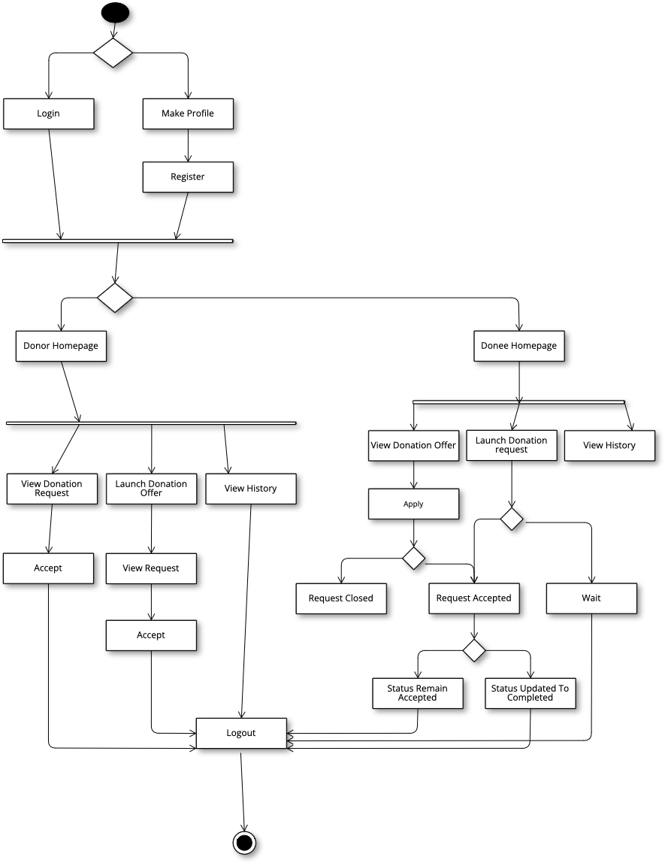

**Use Case Diagram:**

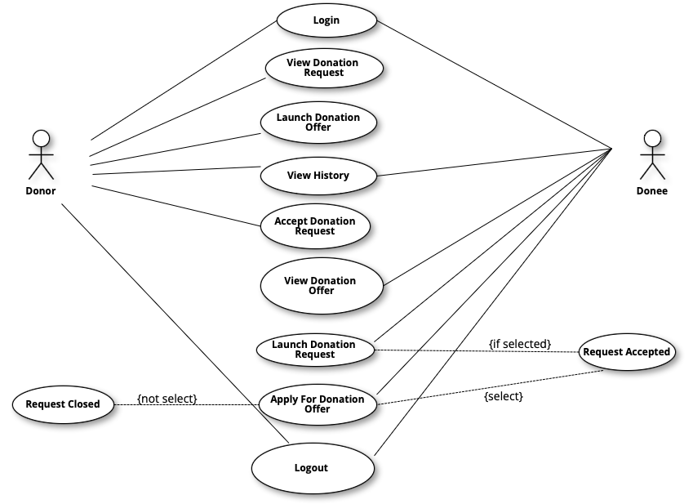

**Context Diagram:**

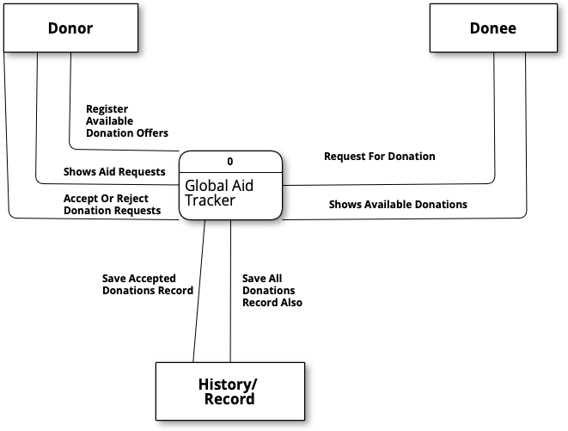

**Data Flow Diagram:**

